## **Introduction**

Nowadays, people are busy in their daily life and having a lot of stress from their working area. Most of them would like to have a pet to accompany them in their daily life and also can release the stress that they received. For example, having a dog or cat is a good choice for most people who love a pet. Pet not only a very good companions and also having deep emotional tie between people. Pet will protect the people with literally lay down their lives.

This website is for the people with animals often enjoy a better quality of health and well-being because of the positive effect of having an animal companion. It is implemented with Sublime Text.

Having a dog as a pet help the owner stay connected with the social life. The owner needs to bring their pet go out for exercise, take the pet to visit the pet groomer and also having the veterinary checkups for their pet. All of these need the owner to communicate with others and involved themselves in the social activities. Besides that, people can get more friends with those who having the same habit which is taking their pet go out for some exercise and activities.   
 Moreover, nowadays people who live in the city are lonelier than people who live in the town. Most of them having the working stress, their communicate problems with other people and all of these will make them feel lonely and no way to release their stress and loneliness. Having a pet such as dog or cat can help them to being more cheerful in their life and easy to communicate with other people.

In this project, a website will be developed that selling the pets such as dogs and cats, pet accessories, sharing knowledge for pet grooming, foods and training. The website name is “CBM Pet Shop”.

## **Objectives of the System**

The CBM pet shop website is about selling dogs and cats. This website is for the users who want to know about pets. And a variety of pet accessories are sold in this website. The objectives of the system are as follows:

* To know information about pets
* To share knowledge about how to care their pets
* Able to order various pets and their accessories easily

## **Data Flow Diagram for the System**

Figure 1: Data Flow Diagram for the System

**WireFrame of the system**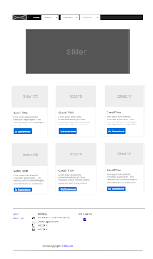

Figure 2 – Home Page on Desktop View

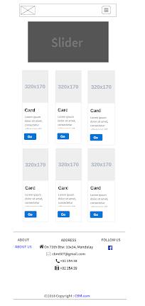

Figure 3 – Home Page on Tablet View

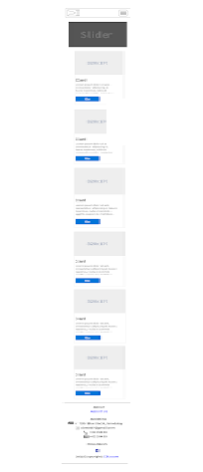

Figure 3 – Home Page on Mobile View

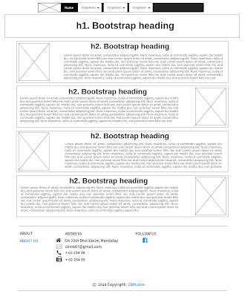

Figure 4 – Information menu Page on Desktop View

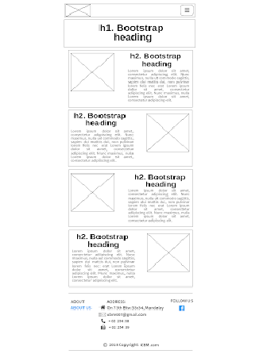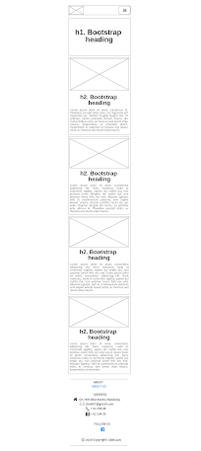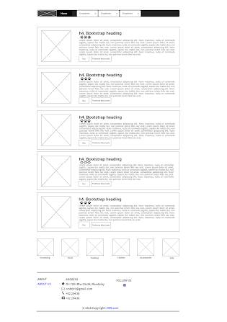

Figure 5 –Information menu Page on Tablet View

Figure 6 – Information menu Page on Mobile View

Figure 7 – Information menu on Desktop View

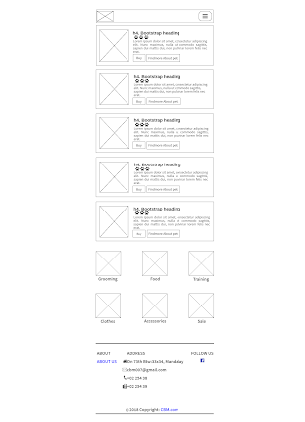

Figure 8 – Information menu on Tablet View

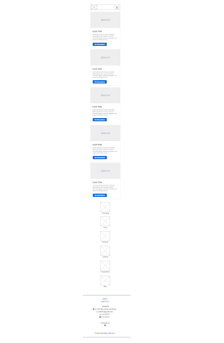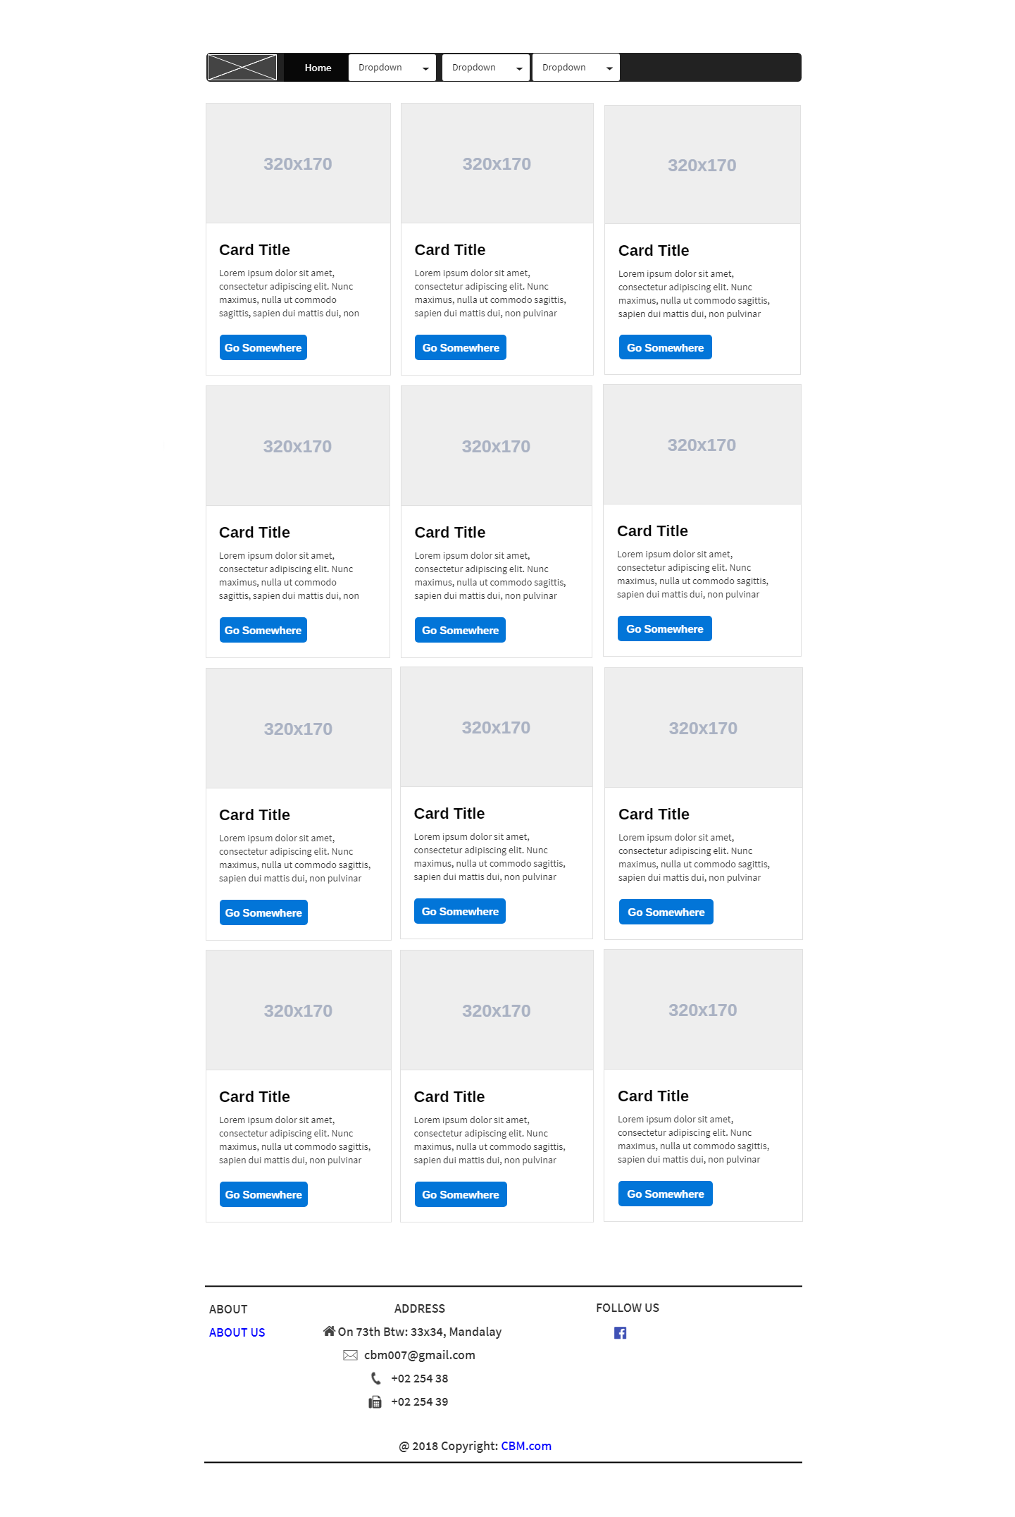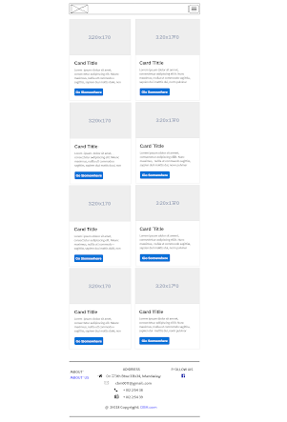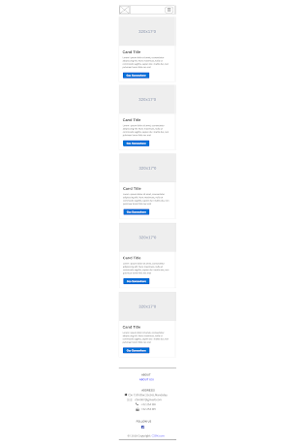

Figure 9 – Information menu on Mobile View

Figure 10 – Discount Items on Desktop View

Figure 11 – Discount Items on Tablet View

Figure 12 – Discount Items on Mobile View

**Conclusion**

Our website is implemented to offer pet tags. The user can reduce time consuming and cash just viewing our website. The user can also know how to care their pets' food, grooming and how to dress their pets because our website is sharing about these. As this website is implemented in a way to be user friendly, the user won't face any difficulties. But our website requires to update timely, cause new services can be still added to this website.